PROJECT REPORT

WORDPRESS - BLOGGING

|  |  |
| --- | --- |
| **DATE :** | 30 OCTOBER 2023 |
| **TEAM LEAD** | PRIYADARSHINI R  B6B7F7CA2742A33D15647BB610D19C04 |
| **TEAM MEMBER 1** | SHAHID MALIK A  3C947AB35B7889D88D6439B0330326FC |
| **TEAM MEMBER 2** | SAMPREETHA S  2C766EDDFFAA6CE8C5640145A53159B2 |
| **TEAM MEMBER 3** | SHREE G  51D7728E9E20567B3354DA454596B598 |
| **PROJECT NAME :** | WORD PRESS – BLOGGING |

# DEFINE PROBLEM / PROBLEM UNDERSTANDING:

Create a first blog- 500-800 words on workpress blogs (grammarly, COPYAI) and promote the blog on any of the social media of your choice not by posting the blog directly but by creating a promo link for the blog and attract a minimum of 50 Likes on the blog.

**BRAND NAME: “SUVAI ARUMBUGAL”**

**CATEGORY:** Digital marketing

**EMAIL ID:** [suvaiarumbugal007@gmail.com](mailto:suvaiarumbugal007@gmail.com)

**WORDPRESS BLOG URL:** <https://suvaiarumbugal3.wordpress.com/2023/10/26/bon-vivanta/>

**POST INTO SOCIAL MEDIA WEBSITE:**

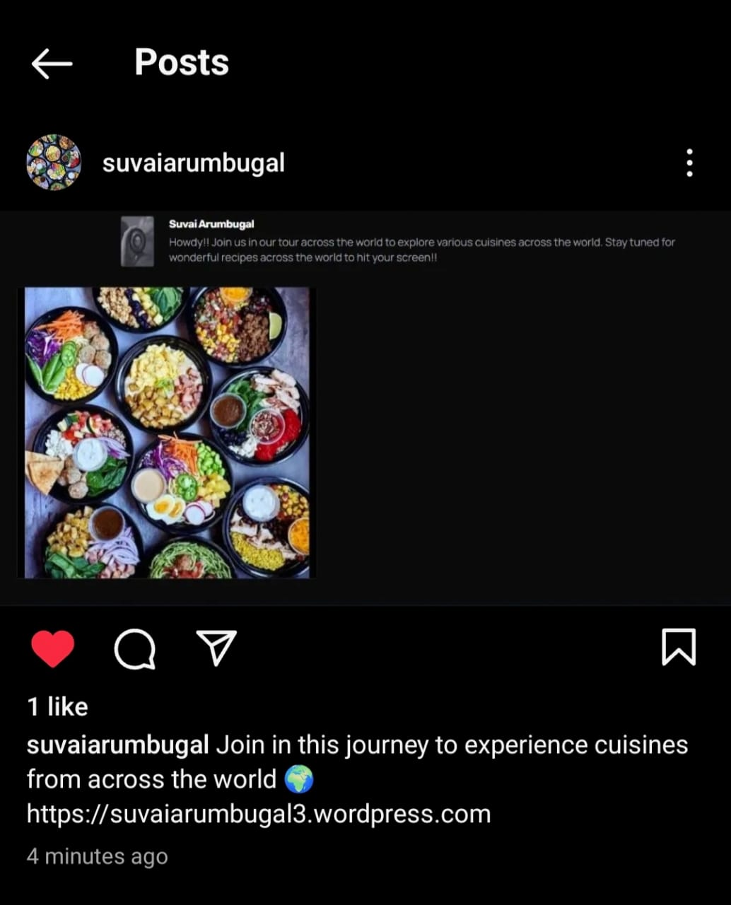

# DOCUMENTATION:

1. **CREATE A GMAIL ACCOUNT:**

Navigate to <https://www.google.com/account/about/> to get a new Gmail account.

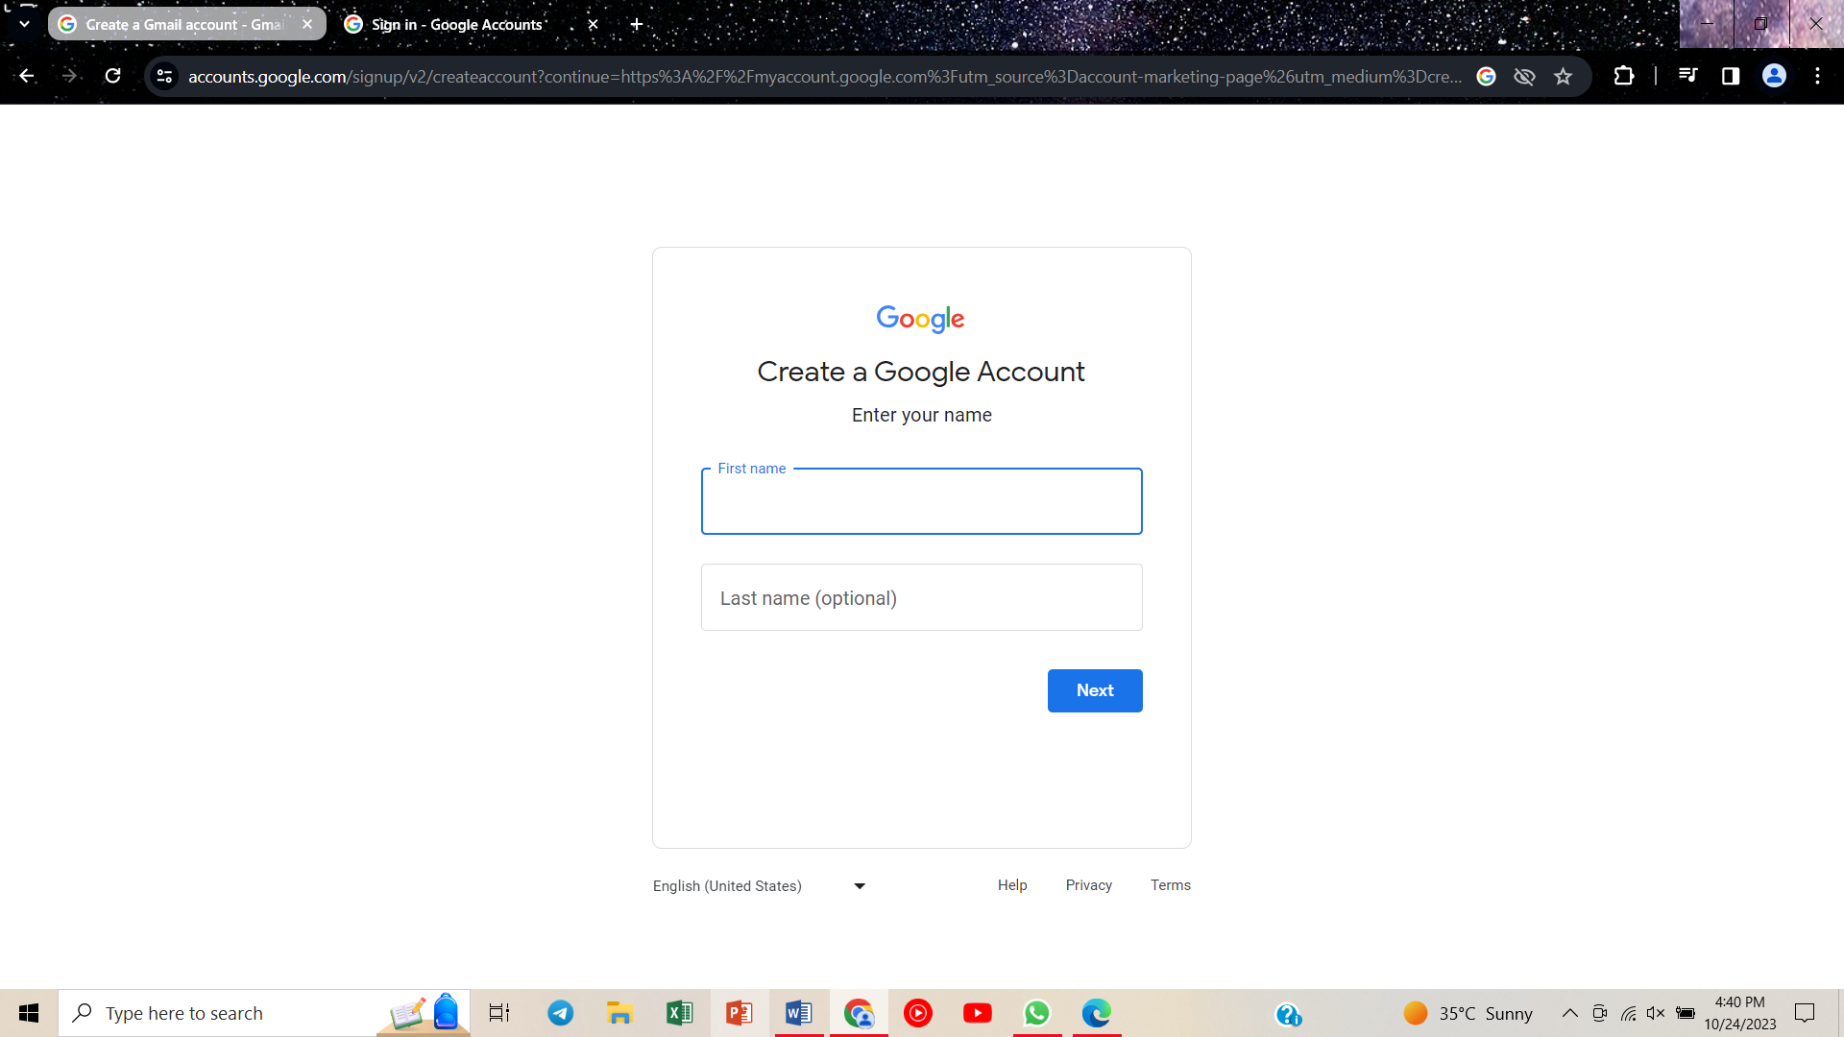

# CREATE AN ACCOUNT IN WORD PRESS

# Navigate to <https://wordpress.com/?aff=27964> WordPress website.

1. **GIVE E-MAIL ID AND CONTINUE:**
2. 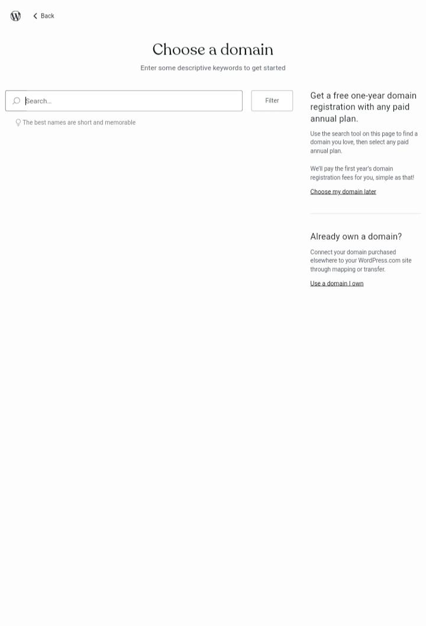**CHOOSE A DOMAIN**
3. **TYPE THE REQUIRED DOMAIN AND SELECT THE ONE THAT IS AVAILABLE FOR FREE**

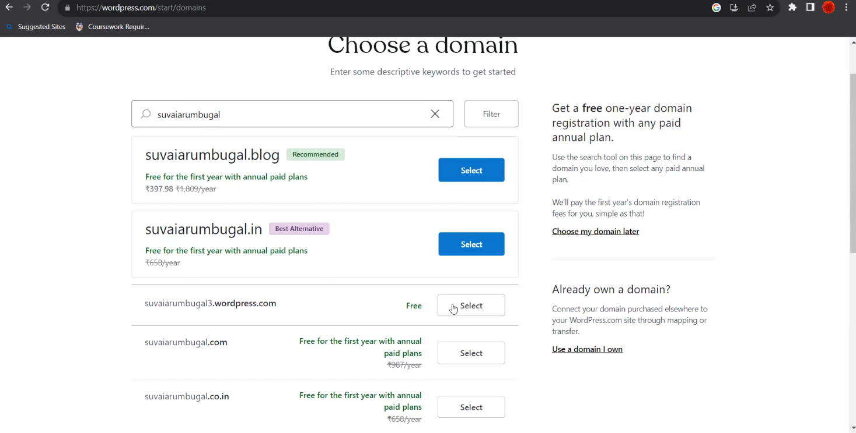

1. **CHOOSE THE PLAN THAT IS FREE**

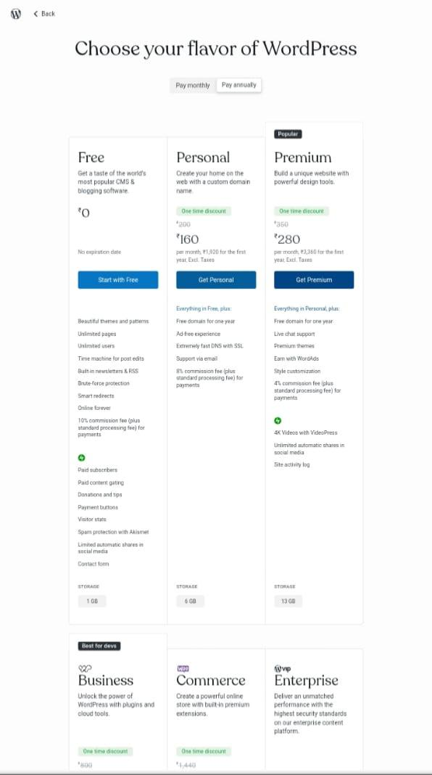

1. **GIVE SKIP TO DASHBOARD**

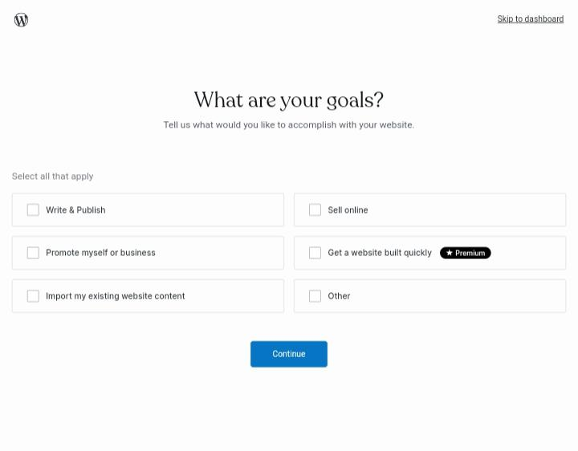

1. **CLICK TO SET UP YOUR SITE**

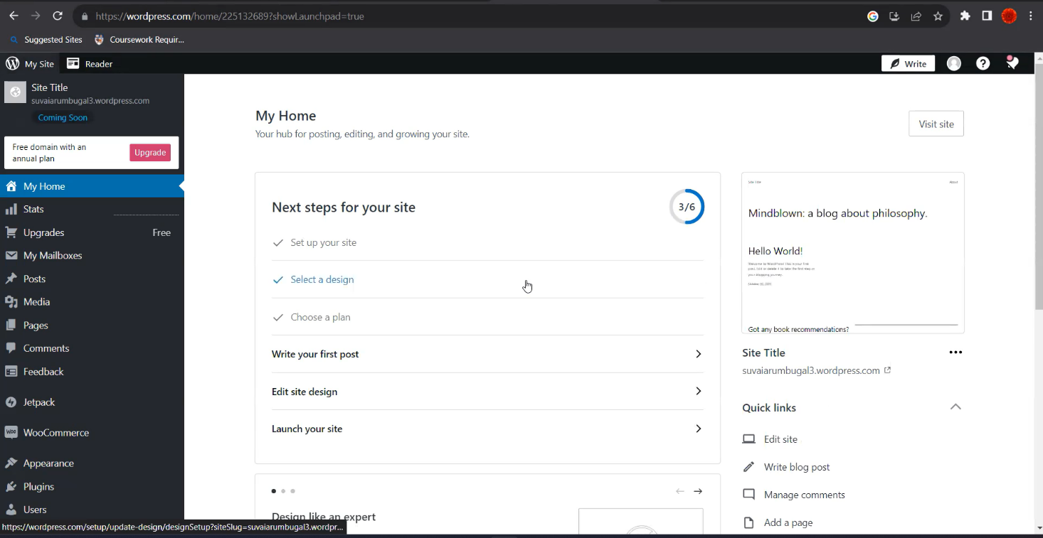

1. **GIVE SITE TITLE AND TAGLINE AND SAVE THE DETAILS**

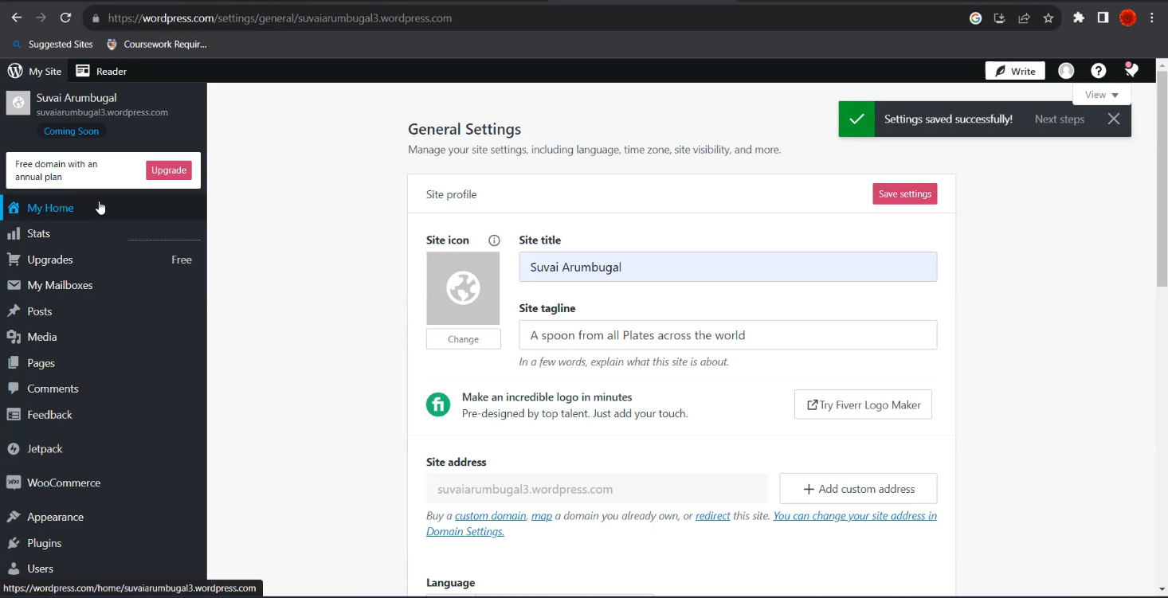

1. **CHOOSE : SELECT A DESIGN**



1. 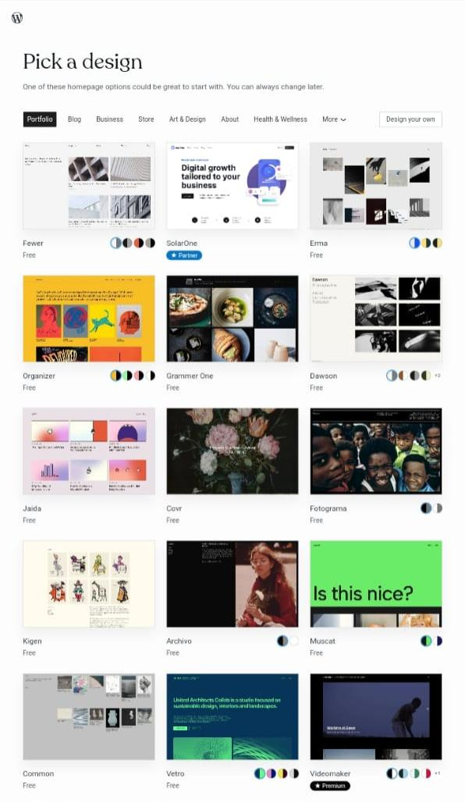**CHOOSE ONE OF THE DESIGN**
2. **GIVE CONTINUE**

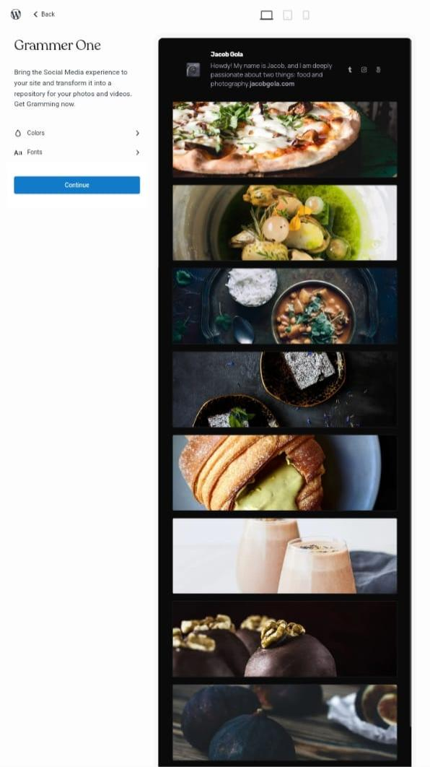

1. 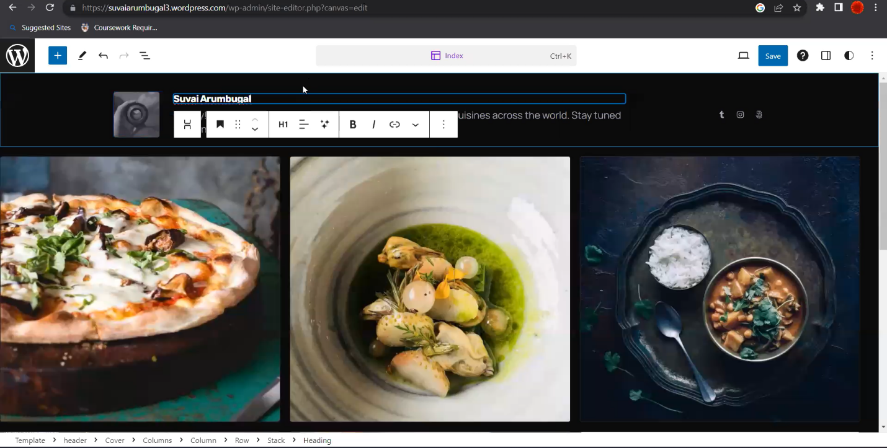**CHOOSE EDIT SITE DESIGN & EDIT THE HEADING AND CONTENT**

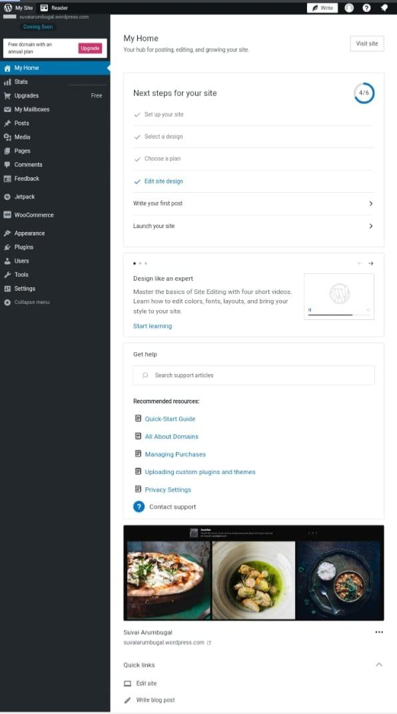

1. 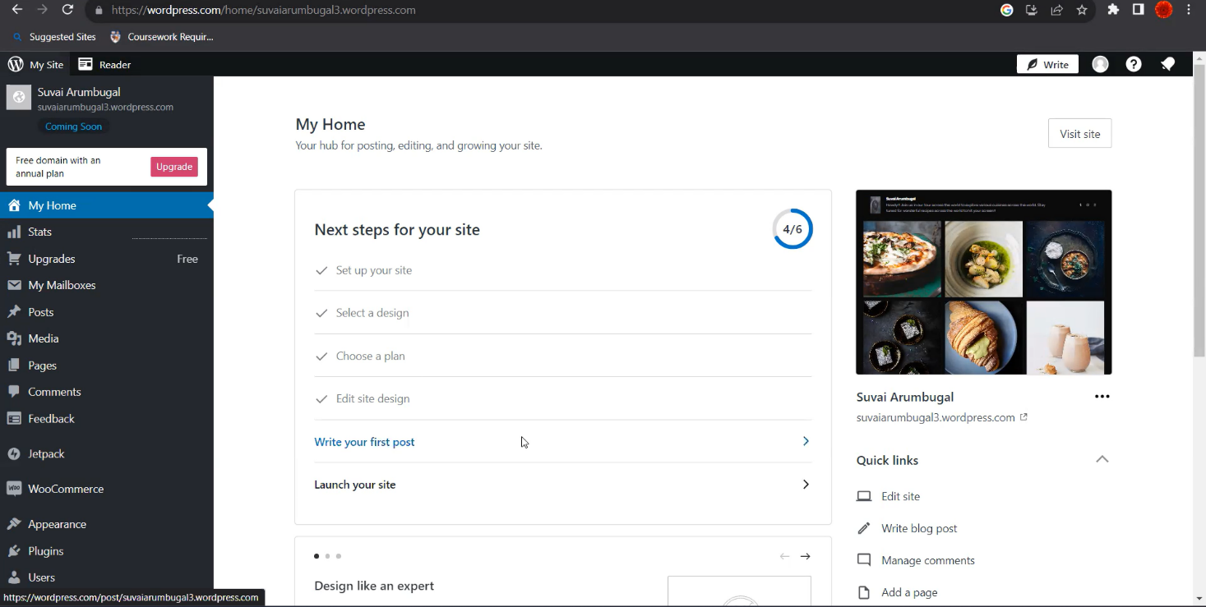**GO TO WRITE THE FIRST POST**
2. **GIVE THE TITLE AND CONTENT**

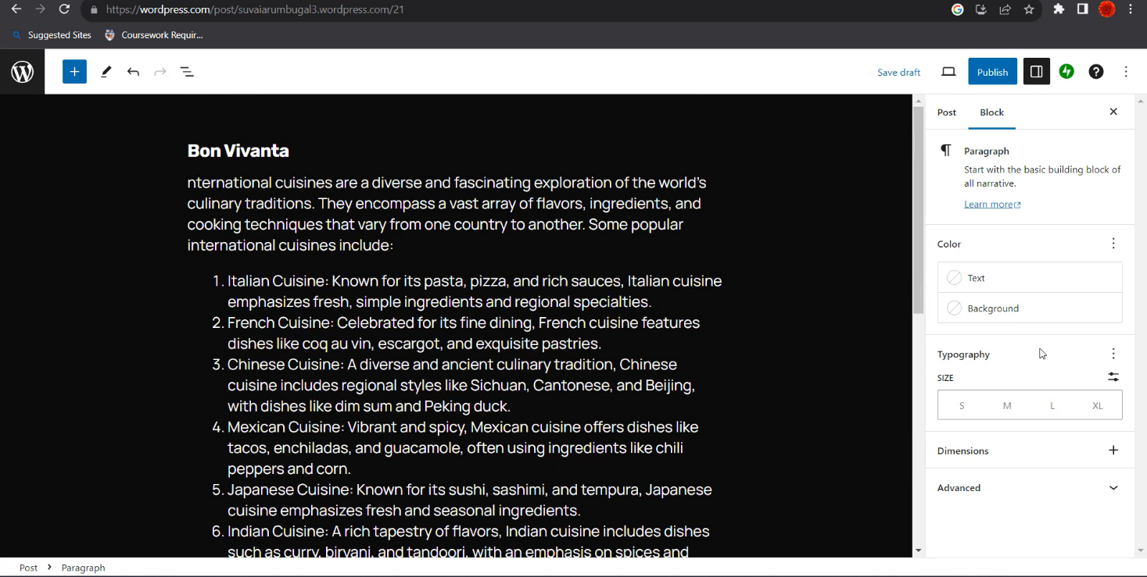

1. **SELECT FEATURED IMAGE & SELECT IMAGE FROM GALLERY**

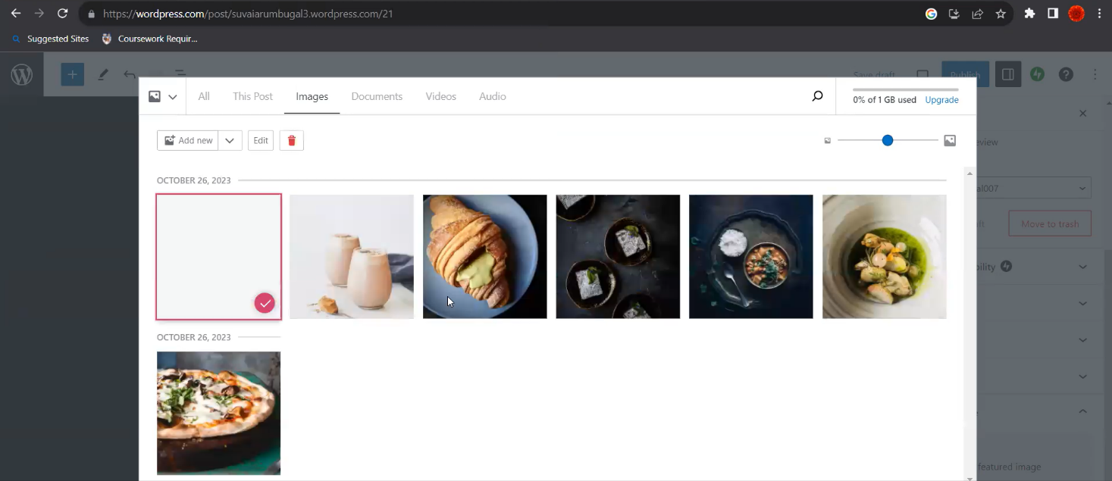

1. 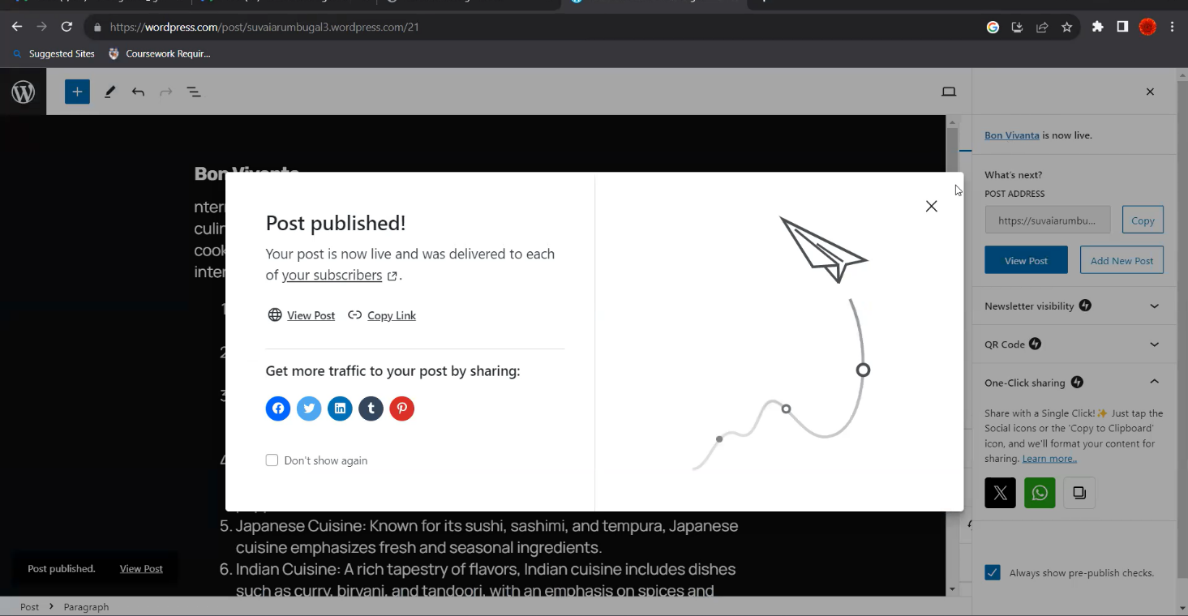**GIVE PUBLISH**
2. **GO TO LAUNCH YOUR SITE:**

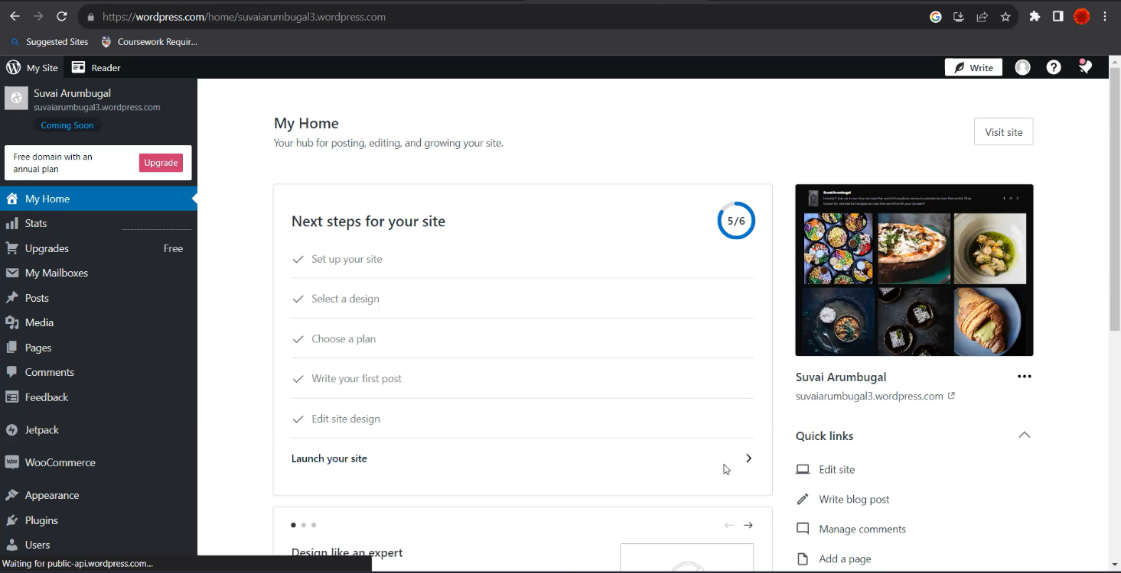

1. **SITE WILL BE LAUNCHED:**

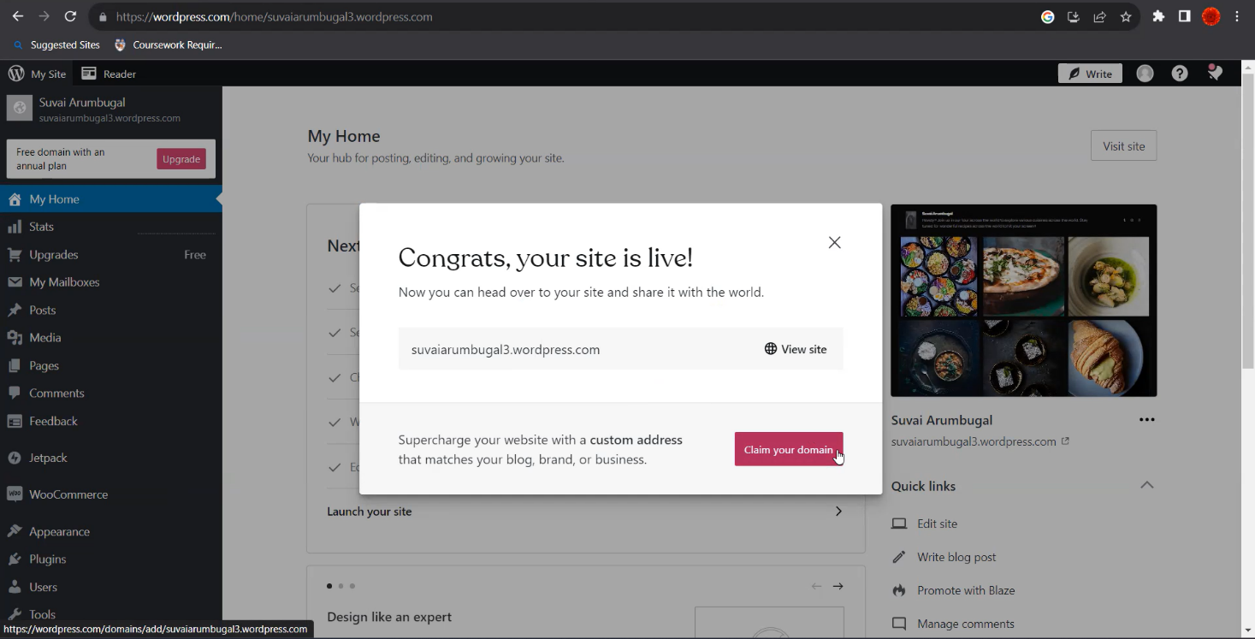

1. **CHECK IN POST FOR THE BLOG**

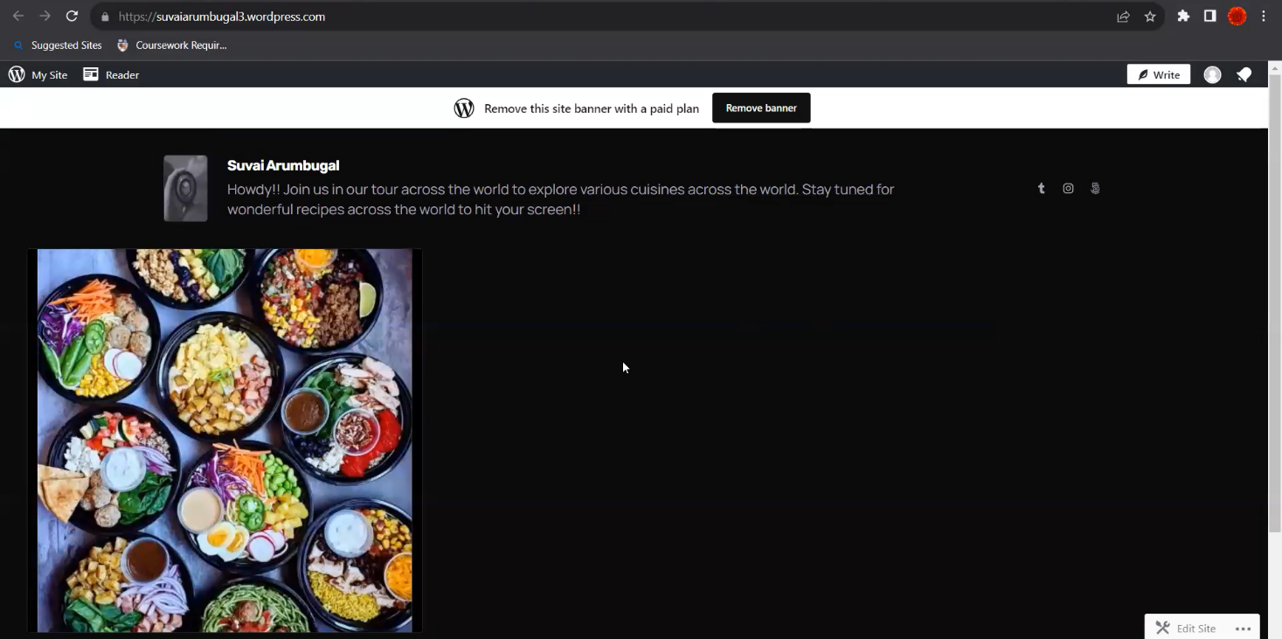

**GitHub LINK:** [**https://github.com/Priya-Darshinir/Wordpress-Blogging**](https://github.com/Priya-Darshinir/Wordpress-Blogging)

**RECORDED VIDEO DRIVE LINK:**

[**https://drive.google.com/file/d/1IWEBrU_iGFHREUcHcmxoNjlHV92_3me2/view?usp=drivesdk**](https://drive.google.com/file/d/1IWEBrU_iGFHREUcHcmxoNjlHV92_3me2/view?usp=drivesdk)